U.S. History
WWI Projects
Peer Grading Sheet
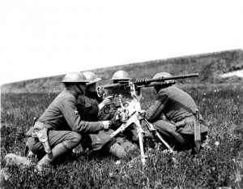

Directions: Each member of the group was expected to contribute to the project. Part of your grade will
come based on your effort as a project partner as determined by your peers. Please grade
each member of your group out of 5. (circle one)
- 5 being the best and meaning that this group member was a major contributor, giving full
effort and full input to the project. Group member contributed good ideas and information and was a big part of putting the project together in a successful way.
- 1 being the lowest and meaning that this group member was of very little help and rarely
spent their time contributing to the success of this project. This member may have refused, forgotten, or failed to provide information, effort, or resources necessary for this project to be its best.

Your Name:___________________________________

Group Member: ______________________________ 5 4 3 2 1

Group Member: ______________________________ 5 4 3 2 1

Group Member: ______________________________ 5 4 3 2 1

Group Member: ______________________________ 5 4 3 2 1

Comments:

